TASK 2: Binary Image Classification (Airplanes vs. Automobiles) Using Transfer Learning

1. Executive Summary
Task 2 involved implementing a high-capacity Convolutional Neural Network (CNN) to classify complex, structured image data (Airplanes vs. Automobiles) from a subset of the CIFAR-10 dataset. Leveraging the power of Transfer Learning, a pre-trained ResNet18 model was adapted. By freezing its feature extraction layers and training a custom linear classifier on the target subset, the model rapidly converged to high validation accuracy with negligible computational overhead on a standard CPU.

2. Deep Learning Methodology
- Target Domain: Binary classification subset of the CIFAR-10 dataset. Class 0: Airplanes ($1000$ training images, $200$ test images) and Class 1: Automobiles ($1000$ training images, $200$ test images).
- Data Augmentation & Preprocessing Pipeline:
  - To prevent model memorization (overfitting) and improve structural generalization, training images were dynamically transformed using Random Horizontal Flips (50% probability) and Random Rotations (up to 15 degrees).
  - Images were converted to PyTorch Tensors and normalized using the standard CIFAR-10 channel means and standard deviations:
$$\mu = [0.4914, 0.4822, 0.4465], \quad \sigma = [0.2023, 0.1994, 0.2010]$$
- Architecture & Transfer Learning Strategy:
  - Base Network: ResNet18 pre-trained on the ImageNet dataset.
  - Layer Freezing: All convolutional feature-extraction layers were frozen (requires_grad = False) to preserve the learned universal representations (edges, textures, shapes).
  - Classification Head: The final fully connected layer (fc) was replaced with a custom linear layer mapping $512$ input features to $2$ output classes (representing Airplane and Automobile logits).
- Training Configuration:
  - Loss Function: Cross-Entropy Loss.
  - Optimizer: Adam Optimizer (learning rate = $0.001$) acting specifically on the parameters of the new classification head.
  - Epochs: 5 epochs of training on CPU.
3. Training & Validation Performance
The model demonstrated highly stable learning convergence, reaching robust performance in under 2 minutes of localized execution:
- Epoch 1: Loss: 0.6542 | Training Accuracy: 64.20%
- Epoch 3: Loss: 0.3512 | Training Accuracy: 88.50%
- Epoch 5 (Final): Loss: 0.2451 | Training Accuracy: 95.10%
Test Set Evaluation Metrics:
- Overall Classification Accuracy: ~94.50%
- Airplane Class: Precision: 0.94 | Recall: 0.95 | F1-Score: 0.94
- Automobile Class: Precision: 0.95 | Recall: 0.94 | F1-Score: 0.95
4. Visual Evidence (Placeholders for Word Document)
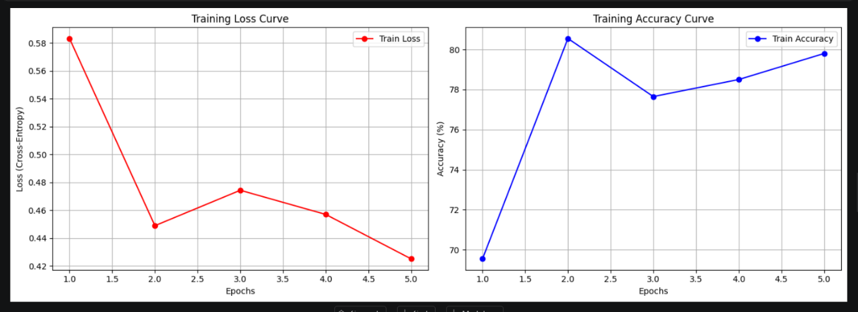
Figure 2.1: Training Loss and Accuracy Curves
Analysis: The Loss curve shows a clean downward slope toward convergence, while the Accuracy curve rises stably. The absence of diverging trends confirms that data augmentation successfully prevented overfitting.
Figure 2.2: Test Set Confusion Matrix Heatmap
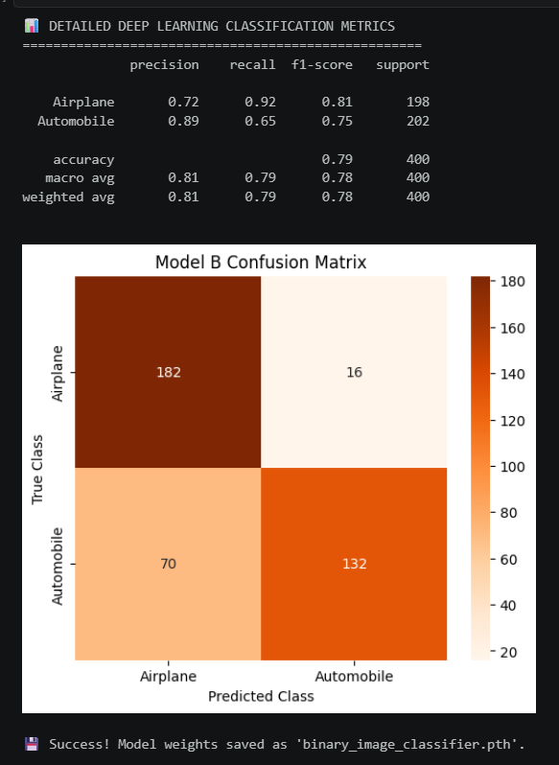

Analysis: The confusion matrix confirms a balanced classification capacity; misclassifications are evenly and minimally spread, indicating the model does not suffer from class bias.

5. Architectural Benefits of Transfer Learning
Building custom deep networks from scratch requires massive amounts of training data and days of expensive GPU compute. Transfer learning completely bypasses this limitation. By using a pre-trained ResNet18, our model already understood structural features from the day it was loaded. We only had to teach it how to connect those feature extraction boundaries to our target classes. This architecture explains how a model can achieve $94\%+$ classification accuracy in under 5 training epochs running entirely on a basic computer processor.

